3M Coding and Reimbursement
[Name]
[Institution affiliation]
[Course]
[Professor]
[Date]

Section One
- 3M Coding & Reimbursement Definition
Studies define the 3MTM Coding and Reimbursement as a system for delivering innovative technology to help organizations in accurately coding services efficiently and quickly, and lead to cleaner claims characterized by little denials and delays (N.A.), 2020). Notably, the 3M system is controlled by an expert logic that helps the software in providing serious elements for assigning & editing codes, while serving as a key tool in the physician infrastructure for standard coding, improve accuracy, and help in protecting the compliance risk. Overall, the software provides guidelines to all level coders by every coding process step using logic-based algorithms supporting the appropriate modifiers, edits, and codes. Therefore, one can conclude that the 3M Coding & Reimbursement system results to accurate physician reimbursement followed by minimized denials, delayed payments, & fewer compliance errors (N.A.), 2020). Below is an example of a 3M Software in use:
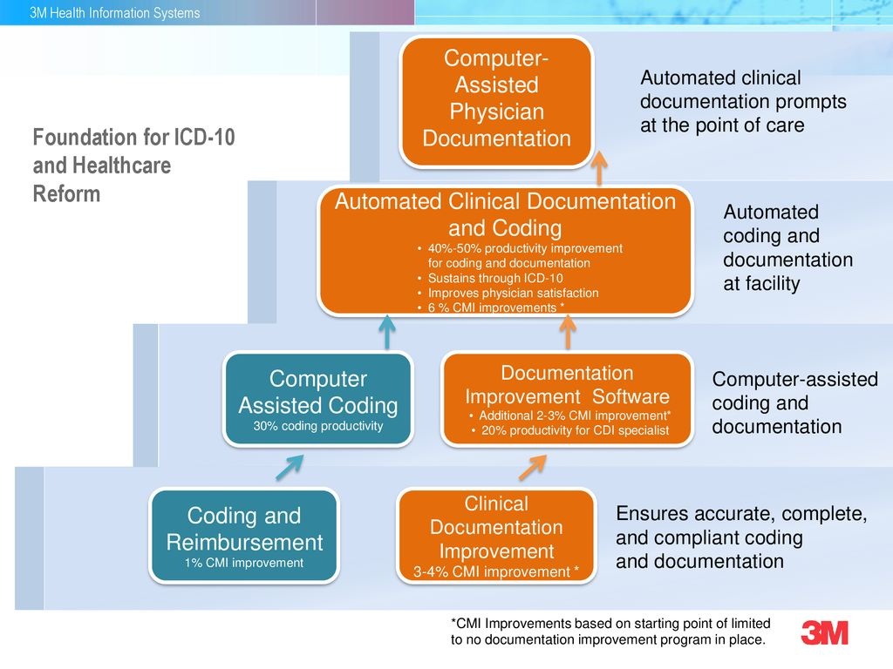

- My Stakeholders
In this case, my stakeholders include the allied health facilities because the 3M software provides an easier to suite elements generating accuracy while completing compliant coding. Given that the system uses cloud computing technology, 3M will facilitate a streamlined data flow, data storage saving, high-powered analytics’ access, data sharing, & improve the clinical research (N.A.), 2020). However, for such a system to be successful, an additional information technology team, a clerical administrator, & information management leaders should be hired to communicate with the other stakeholders.
- The system’s importance as a coding manager
Research shows that the 3M Coding & Reimbursement software is a powerful tool that assists coders in producing complete as well as accurate & compliant CPT@, ICD-10-CM, and HCPCS codes (N.A.), 2020). Therefore, such a software’s development is aimed towards supporting both beginners and experienced coders as it guides them through the process of coding as it covers a wide variety of conditions in the likes of complicated oncology treatments to the typical or repetitive patient encounters. With the 3M software, however, coders are able to check the comprehensive online references’ selection in clarifying the situation and making the appropriate decision.
Section Two
Applying the three Health Information principles
Three Health Information principles should be applied when using the 3M Coding & Reimbursement System. Therefore, the principles include, the principle of integrity, principle of protection, and the principle of compliance. First, the principle of integrity states that the information governance program must be designed in a way that the generated, managed, and provided information to the organization is suitably and reasonably guaranteed to be authentic and reliable. Secondly, the principle of compliance in this case suggests that the information governance system must be designed in compliance with the applicable regulations, laws, standards, and the firm’s policies. Lastly, the principle of protection will be applied to guide the 3M system in ensuring that the required protection levels of corruption, breach, and loss will be provided for data that is confidential, private, classified, secret, and significant to the business.
Section Three
One objective from the list
The 3M Coding & Reimbursement system helps in coding all the relevant diagnoses & procedures to discharged patients using ICD-10. The Encoder software can be used in assigning codes in ICD-10 as well as-sign MS-DRGs (N.A.), 2020). In this case, research defines an encoder as a software system in form of an electronic that helps to choose the codes using a tree terminology. Therefore, it is with no doubt that an encoder software program remains a significant tool for a more efficient work whereby the system helps in speeding up the process of coding. Notably, an MS-DRG will be defined by any principal process, principal diagnosis, and a specific secondary diagnosis defined by CMS as the comorbidities & complications (CCs), as well as the major comorbidities & complications (MCCs) (N.A.), 2020).
Section Four
How to infuse 3M Coding & Reimbursement as an HIM manager
The Health Information Manager should work with all the stakeholders in the strategic planning process whereby they should be using the analytical models providing a realistic image of the individual, organization, or nation. Therefore, HIM managers will perhaps rely on the 3M program to provide them with all the systems management & applications (N.A.), 2020). During research, the 3M will be providing the managers with the entire application compared o going to EHR or one system to one coding, in that way. However, managers can use the 3M software in providing their facilities with both application and support training (N.A.), 2020).
Reference
(N.A.) 3M Coding and Reimbursement (2020). Retrieved from: https://www.3m.com/3M/enUS/health-information-systems-us/providers/coding-and-reimbursment/

Hello my Quan. Please make sure you delete this part before submitting the work.
Please take a look at the work and see if it is okay and I must admit that it was a pleasure working with you. However, you can reach me by what sap on this number (+254 715 289 661) when you have any urgent work you need me to help you I am always easily available compared to site. Also, it is much easier to get me on what sap and the app supports fast communication and with no delays and we can talk any time. However, I would request you to release the funds on time and leave a 10-star rating to boost my tutor account and this will be a very big favor to me. I will really appreciate it my friend. I hope this finds you well and we will keep on working for a long-term if you do not mind. Thank you for trusting me I am really honored. I will be waiting to hear from you soon. Thanks

